Philippine Conference on Multidisciplinary Research 2019
April 27-29, 2019
Hotel Supreme Convention Plaza, Baguio City, Philippines
Co-hosted by:

OBSERVER REGISTRATION FORM

Theme: “Developing Research Skills Across Disciplines”

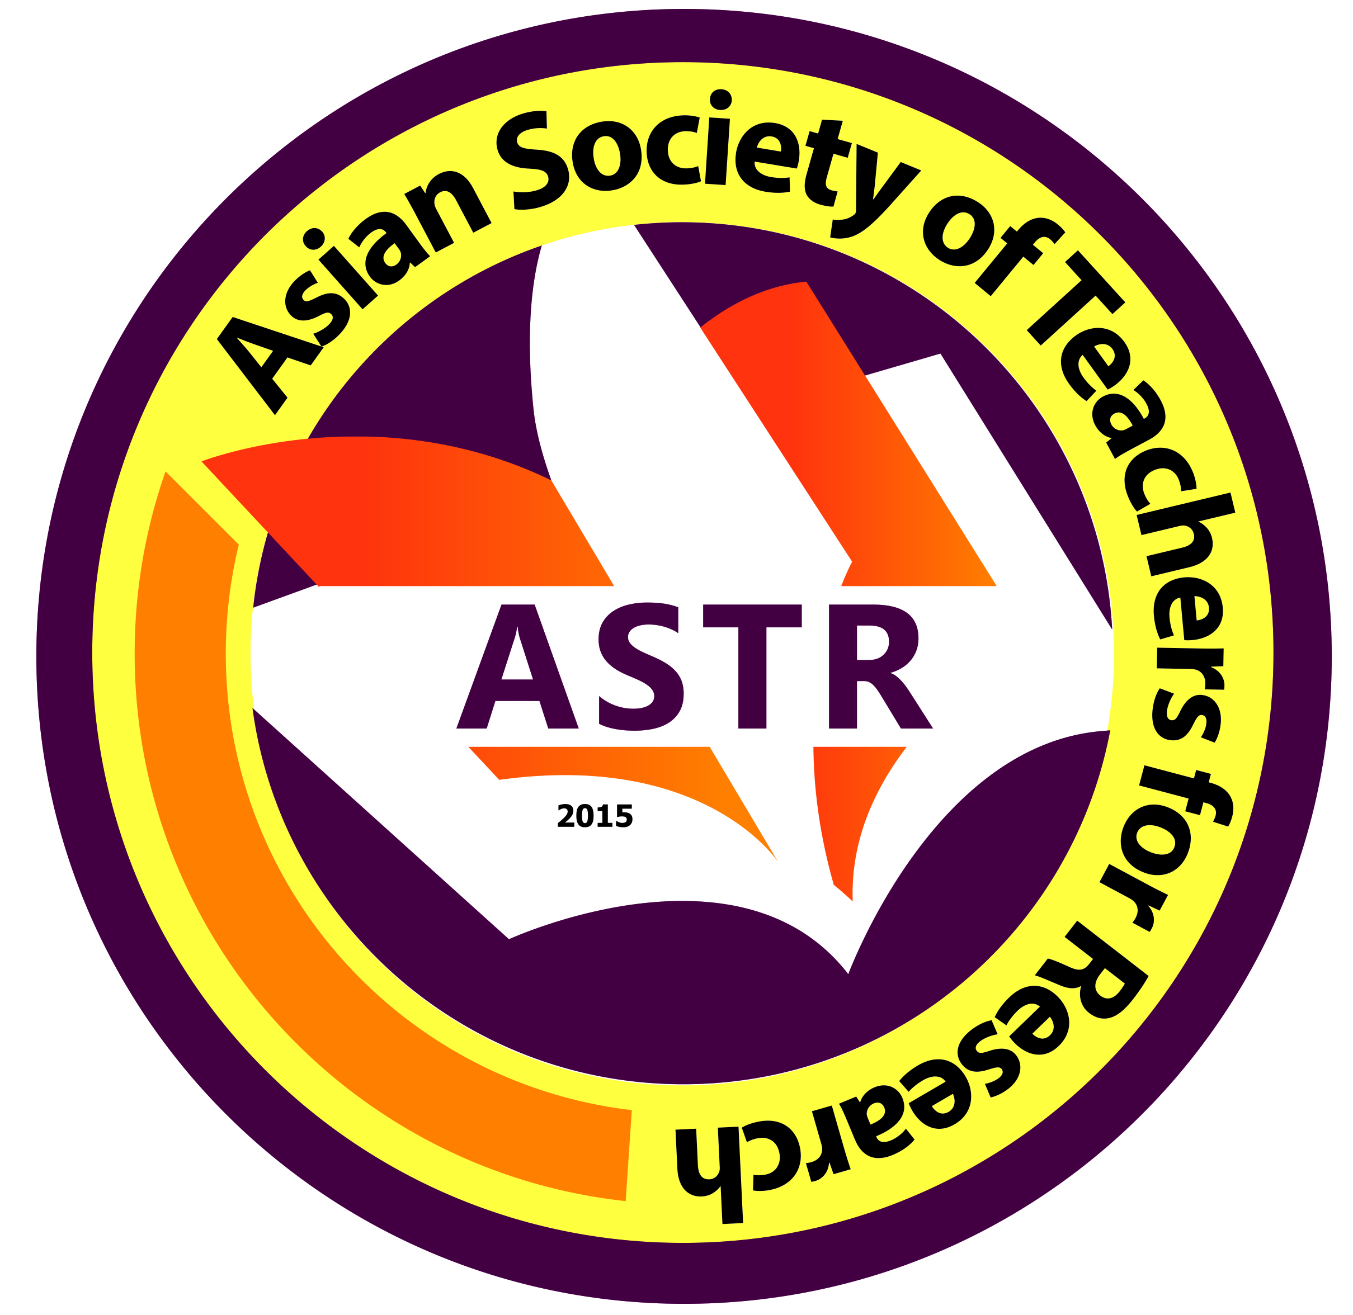
Date Filed:
First Name:
Middle Name:
Last Name:
Email Address:
Mobile No. (begin with country code):
ORCID No (register at www.orcid.org):
Field(s) of Expertise:
Organization/School/University/Affiliation:
Address of Organization/School/University/Affiliation:

*Please attached the following documents together with this filled-out form:
(a) formal ID Photo;
(b) Updated Curriculum Vitae;
(c) deposit slip

